37.50: One dimension of the cube appears contracted by a factor of 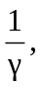 so the volume in 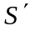is 